Designing Solutions

|  |  |  |  |
| --- | --- | --- | --- |
| **Algorithm A** | |  | **Algorithm B** |
| 01  02  03  04 | Num1 ← INPUT  Num2 ← INPUT  Total ← Num1 + Num2  OUTPUT DISPLAY |  |  |

1. Which of the example algorithms is in the form of pseudocode? (1)

|  |
| --- |
|  |

2. Describe the purpose of Algorithm A. (3)

|  |
| --- |
|  |

3. Draw the flowchart symbol that matches each description. (5)

|  |  |
| --- | --- |
|  | Used to control the path taken through an algorithm based on the result of a condition. |
|  | Used to indicate the start or end of an algorithm. |
|  | Used to indicate a process, for example performing a calculation. |
|  | Used when data needs to be inputted or outputted. |
|  | Used to call a pre-defined algorithm. |

4. A security light is activated when it is dark and movement is detected. The flow chart for this is given below. You need to complete it. (4)

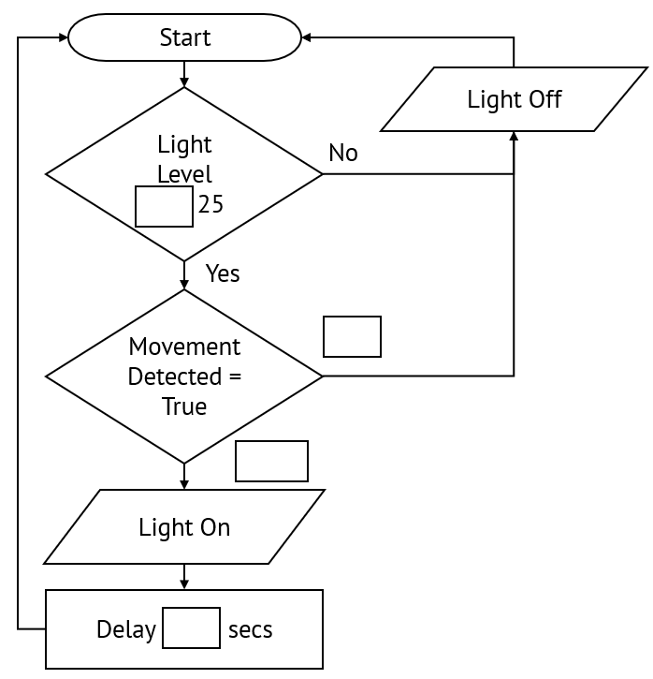

5. Students are completing test. If they score 80 or above they will be given an A grade, if they score 70 or above they will be given a B grade, if they score 60 or above they will be given a C grade, otherwise they will be given a D grade. A program is needed to convert a student’s score into a grade.

a) Use a structure diagram to design a solution to the program given above. (4)

|  |
| --- |
|  |

5 b) Design an algorithm in pseudocode that can be used to convert a student’s score into a grade. (4)

|  |
| --- |
|  |

c) Design an algorithm in the form of a flow chart that can be used to convert a student’s score into a grade. (6)

|  |
| --- |
|  |